15 - 08 Feb 2023 (Kubernetes, Deploy cont)

08 February 2023

20:39

# How to deploy container in kubernetes

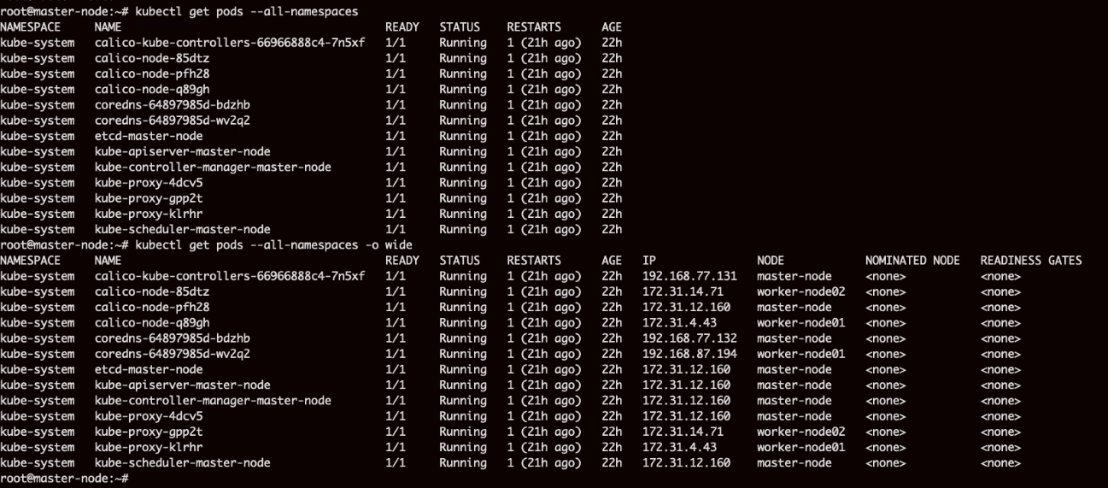

Kubernetes does not create a container

It creates a wrapper around original application container. It is called pod

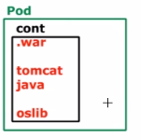

Pod can more than on container running different service of different application

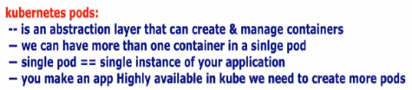

In a pod we cannot multiple container of same application. It should be of different application.

Second container in a pod is called **side-car container**

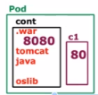

Create a pod

Kubectl run webapp-pod --image-nginx

Every pod containing single image

This command will show pod and node where it is runing

**Kubectl get pods -o wide**

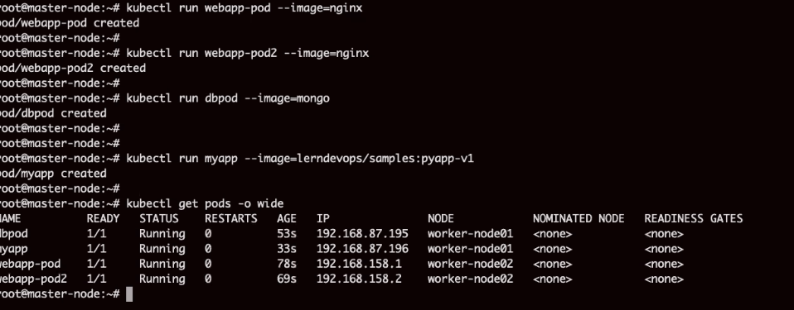

Delete pod

Kubectl delete pod dbpod

Equal to inspect in docker, for investigation

kubectl describe pod myapp

Check log, equal to docker log

kubectl logs webapp-pod

Login to pod and execute some command

Kubectl exec -it webapp-pod -- /bin/bash

Pod Lifecycle

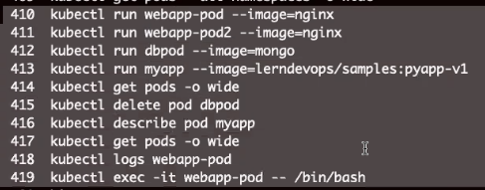

What namespace is doing?

Isolate our pods with system pods

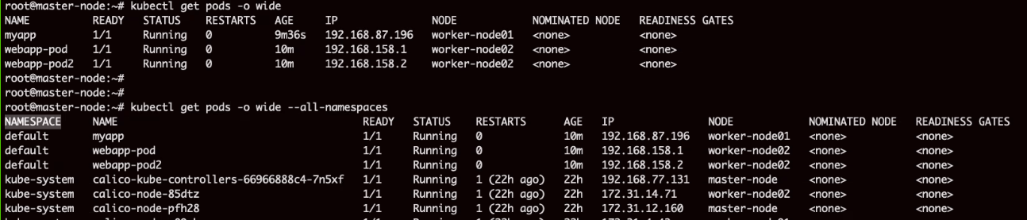

See available namespaces

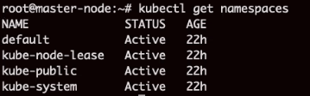

Description of namespace

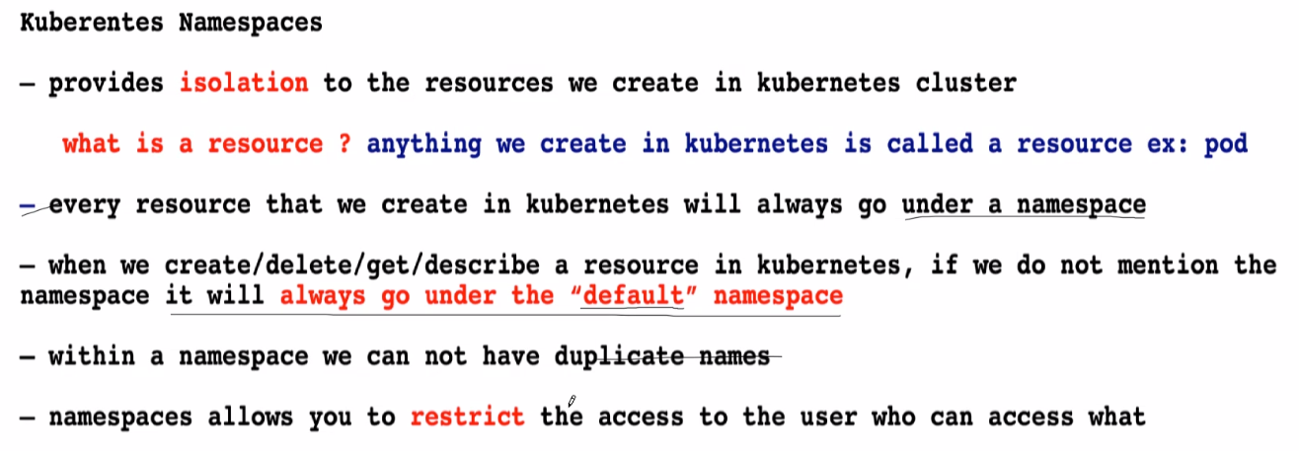

Create namespace

You can create many namespaces

Kubectl create namespace teamA

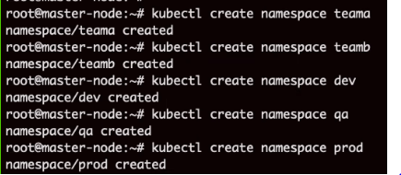

If we don’t give namespace it will look into ddefault namespace

Kubectl get pods-o wide

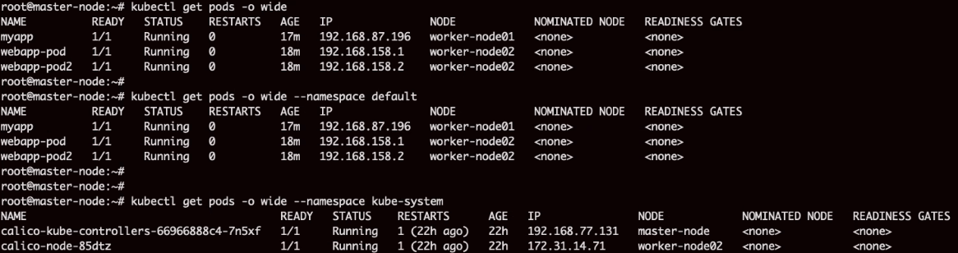

We cannot have same pod name in name namespace

Kubect. Run od1 --image=httpd --namespace teama

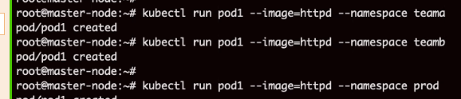

See all namespaces

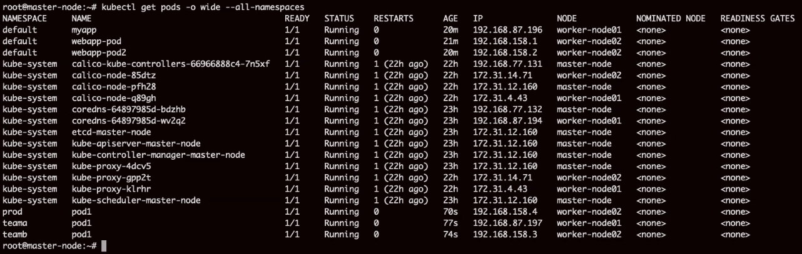

Delete namespace

Kubectl delete pod pod1 --namespace prod



Namespace allows to restrict the access to hte user who can access what

# How to create POD using YAML

Mainly 4 sections

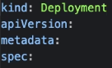

Which all value can come in **kind, apiVersion** can be seen here

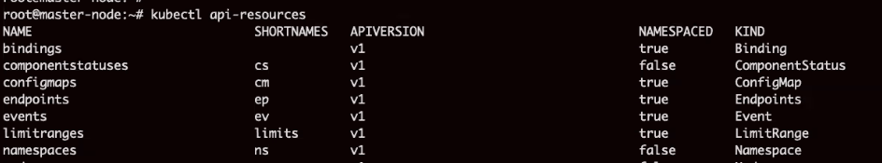

Medata is some information. identify a pod. Name and namespace of pod.

Labels are mandatory. They are like tags. We can identify a group of pods



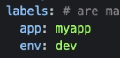

If you don't assign label, kube will assign automatically

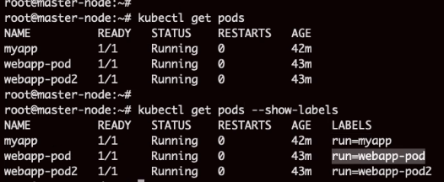

Spec container containers

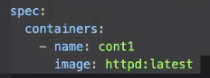

Complete script l ook likethis

Kubectl apply --filename podx.yaml

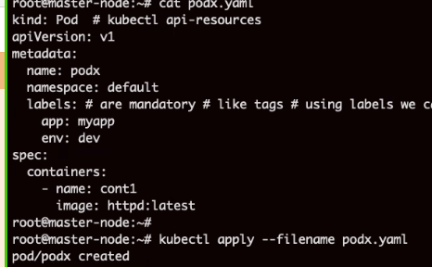

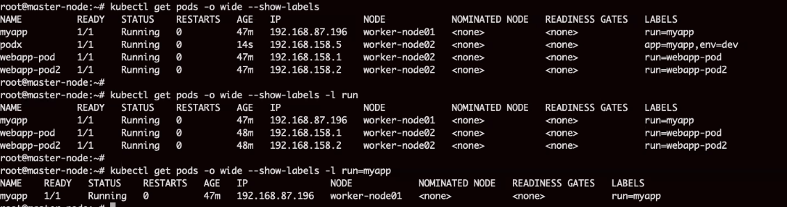

Search using label



# Multi-container pod

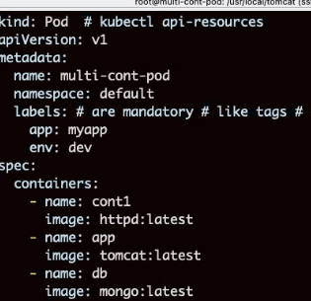

Check log of cont1



If you don't have yaml file, use describe command to check container name

Access each container

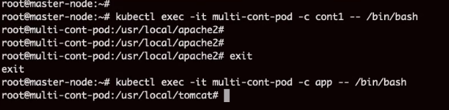

Single IP of pod allows to access multiple applications present in multiple containers

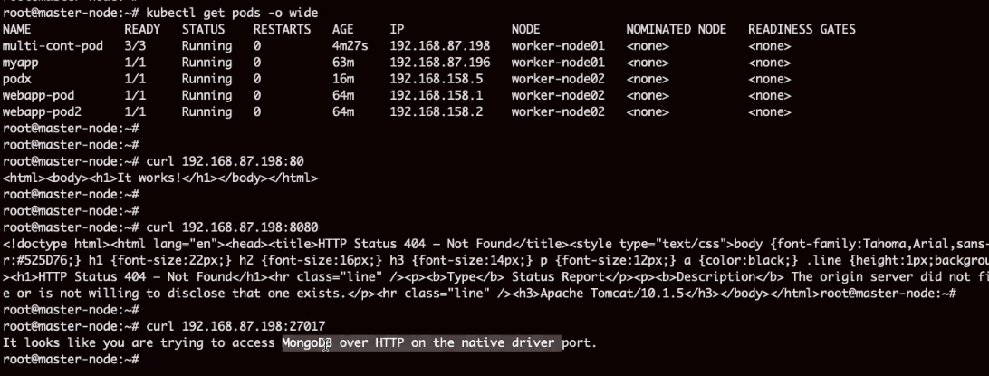

How to create More pods

For high availability , replicate the pods

|  |  |
| --- | --- |
|  |  |

To create controller we will create YAML definition. CMD line is possible but not recommended

Rs.yaml

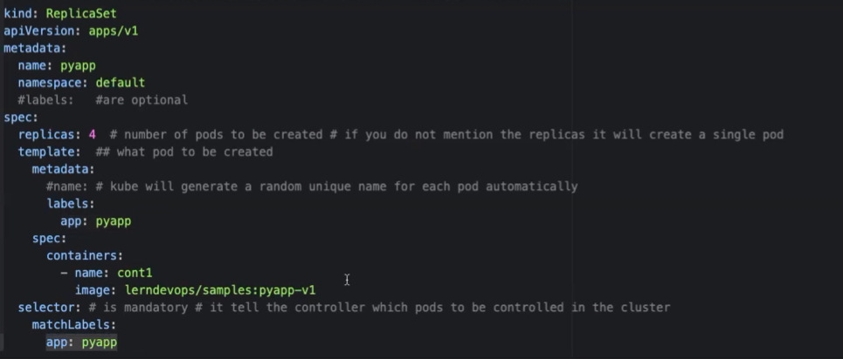

See output

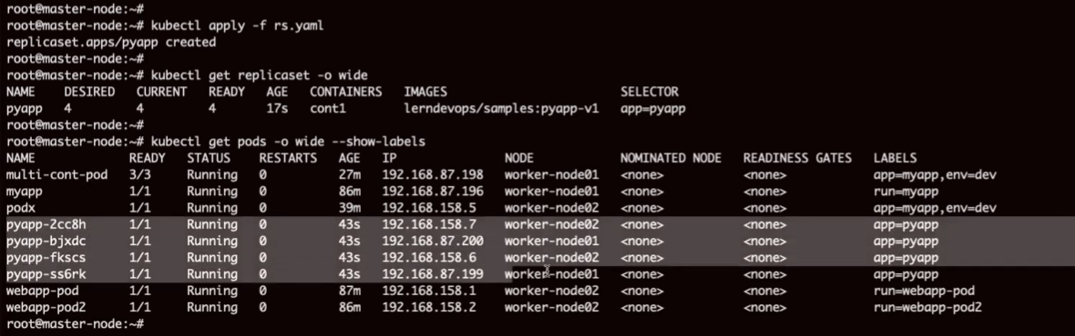

Scale up and scale down

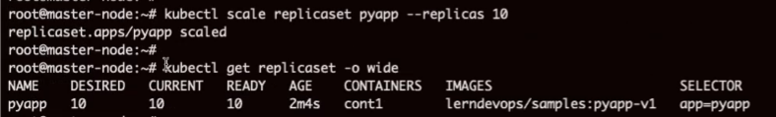

# Desired state maintenance

Desired number of pods will be running at any point of time

Deleted 3 pods. It will recreate 3 pods. System will automatically create 3 new pods to meet desired state

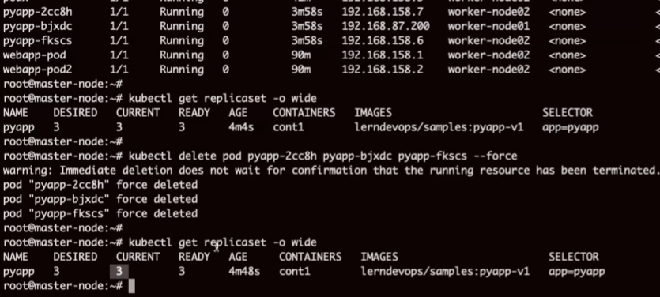

<https://drive.google.com/drive/folders/10j0iSusze8HPxOd9Ni0mbGE5UQWapZFn?usp=sharing>